Daily Notebook & Social Networking Updater
BCA 6th Semester
CS-76(Project)

SK Monirul Islam
Enrollment No-085481170

Table of Contents
Introduction & Objective of the Project: 3
Project Category: 5
Analysis of the Project: 6
Daily notebook & Social Networking Updater GUI 6
View Manger: 7
Common Controls: 7
Engine Interaction: 7
Search Interface 8
Facebook Interface 8
Twitter Interface 8
Daily Note Interface 8
Blogger Interface 8
Linkedin Interface 8
Google buzz Interface 8
Orkut status Interface 9
RSS FEED Interface 9
Task / To Do Interface 9
Archive Interface 9
Daily notebook & Social Networking Updater Engine 10
Task / To Do Handler: 11
Daily Note Handler: 11
RSS Feed Watcher: 11
GUI Interactor: 11
Database Manager: 11
Search Engine: 11
Web Service Handler: 11
Data Update Manager: 11
Daily notebook & Social Networking Updater Database 11
Hardware & Software required for the application to run 12
Hardware Requirements 12
Software Requirements 12
Project Structure: 13
Project Estimation: 13
E-R Diagram: 14
Tools/Platforms used (Hardware/Software): 16
Hardware: 16
Software: 16
Any Client/Industry: 17
Future Scope and Further enhancement of the project: 18

Introduction of the Project:

Nowadays social networking is the main trend among us. We like to share whatever happening with us or around us and follow about others. We want to keep track of every possible thing in our life. Earlier day’s people used to maintain Notebook or Daily Diary to write down about their experiences. Now also we do same things but in different ways. With advent of new technologies we use twitter, facebook instead of maintaining a diary. As all of them are online services we can not access them without an internet connection and sometimes it takes lots of time to load or query our own posts from the server.
Daily notebook & Social Networking Updater will provide a way to organize our daily notes and status updates for social networking sites. It will allow users to add notes and update it to most popular social networking sites. User can add notes anytime and mark it for update, and then whenever user comes online the pending updates will be uploaded to the destination sites. Users will be able to download the RSS feed of the websites and the Daily notebook & Social Networking Updater will automatically download the feeds and make it available for offline view also. The overview of this software is displayed below in the diagram.

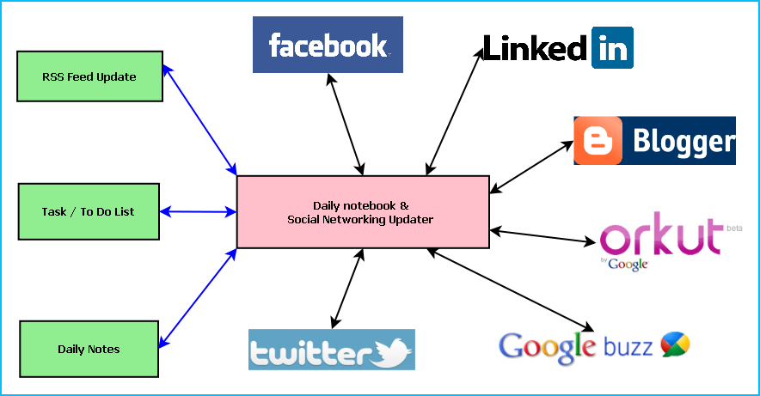
Figure: Overview of Daily notebook & Social Networking Updater

Main features of the Daily notebook & Social Networking Updater are:
- Maintaining daily notes
- Updating the status in Social Networking Sites and downloading the RSS feeds
- Facebook integration
- Twitter integration
- Blogger integration
- Linkedin integration
- Google buzz integration
- Orkut status integration
- Maintaining To Do/Task list
- Reminder/ alarm for scheduled task
- Printing of Notes, To Do & Tasks
- Archiving old data
- Searching Updates

Objective of the Project:
- Single solution for updating any social networking sites
- Keeping track of daily activities
- Timely update whenever internet is available
- To simulate similar experience of Daily notebook.
- To be involved with full-fledged software development
- To know about new technologies like .NET, WPF, Facebook, Twitter.

Tools / Environment Used:

This software will follow Object Oriented Programming Paradigm and use below mentioned areas.

IDE Used (Visual Studio 2010):

Microsoft Visual Studio is a powerful IDE that ensures quality code throughout the entire application lifecycle, from design to deployment. Whether we are developing applications for SharePoint, the web, Windows, Windows Phone, and beyond, Visual Studio is the ultimate all-in-one solution. Visual Studio includes a code editor supporting IntelliSense as well as code refactoring. The integrated debugger works both as a source-level debugger and a machine-level debugger. Other built-in tools include a forms designer for building GUI applications, web designer, class designer, and database schema designer. It accepts plug-ins that enhance the functionality at almost every level—including adding support for source-control systems (like Subversion and Visual SourceSafe) and adding new toolsets like editors and visual designers for domain-specific languages or toolsets for other aspects of the software development lifecycle (like the Team Foundation Server client: Team Explorer).

Front End: WPF (Windows Presentation Framework)
Windows Presentation Foundation (WPF) provides developers with a unified programming model for building rich Windows smart client user experiences that incorporate UI, media, and documents. Windows Presentation Foundation (WPF) is a next-generation presentation system for building Windows client applications with visually stunning user experiences. With WPF, you can create a wide range of both standalone and browser-hosted applications. The core of WPF is a resolution-independent and vector-based rendering engine that is built to take advantage of modern graphics hardware. WPF extends the core with a comprehensive set of application-development features that include Extensible Application Markup Language (XAML), controls, data binding, layout, 2-D and 3-D graphics, animation, styles, templates, documents, media, text, and typography. WPF is included in the Microsoft .NET Framework, so you can build applications that incorporate other elements of the .NET Framework class library.

Programming Framework (.NET 4):

The .NET 4 Framework is Microsoft's platform for building applications that have visually stunning user experiences, seamless and secure communication, and the ability to model a range of business processes. The .Net Framework consists of:
- Common Language Runtime – provides an abstraction layer over the operating system
- Base Class Libraries – pre-built code for common low-level programming tasks
- Development frameworks and technologies – reusable, customizable solutions for larger programming tasks.
The framework's Base Class Library provides user interface, data access, database connectivity, cryptography, web application development, numeric algorithms, and network communications. The class library is used by programmers, who combine it with their own code to produce applications.

Programming Language (C#):
C# is a type-safe, object-oriented language that is simple yet powerful, allowing programmers to build a breadth of applications. C# is a multi-paradigm programming language encompassing imperative, declarative, functional, generic, object-oriented(class-based), and component-oriented programming disciplines. It was developed by Microsoft within the .NET initiative and later approved as a standard by Ecma (ECMA-334) and ISO (ISO/IEC 23270). C# is one of the programming languages designed for the Common Language Infrastructure.
C# is intended to be a simple, modern, general-purpose, object-oriented programming language.

Database Microsoft SQL Server 2008

Microsoft SQL Server 2008 is a complete set of enterprise-ready technologies and tools that help people derive the most value from information at the lowest total-cost-of-ownership. Enjoy high levels of performance, availability, and security; employ more productive management and development tools; and deliver pervasive insight with self-service business intelligence (BI). Its main Highlights are
- Complete information platform for applications of all sizes.
- Managed, familiar self-service BI tools.
- Support for large-scale data centers and data warehouses.
- Opportunities to build and extend applications in the cloud.
- Integration with the Microsoft Application Platform.

Google App Engine (The webapp Framework)

The webapp framework is a simple web application framework you can use for developing Python web applications for App Engine. Webapp is compatible with the WSGI standard for Python web application containers. Webapp provides an easy way to get started developing apps for App Engine.
App Engine supports any Python application with a CGI interface. A web application framework can simplify development by taking care of the details of the interface, letting you focus development effort on your applications features. App Engine includes a simple web application framework called webapp.
Webapp is a WSGI-compatible framework. You can use webapp or any other WSGI framework with App Engine using a CGI adaptor, such as one provided by the Python standard library.

Extensible Markup Language (XML)
Extensible Markup Language (XML) is a simple, very flexible text format derived from SGML (ISO 8879). Originally designed to meet the challenges of large-scale electronic publishing, XML is also playing an increasingly important role in the exchange of a wide variety of data on the Web and elsewhere.
Extensible Markup Language (XML) is a set of rules for encoding documents in machine-readable form. It is defined in the XML 1.0 Specification produced by the W3C, and several other related specifications, all gratis open standards.
XML's design goals emphasize simplicity, generality, and usability over the Internet.[6] It is a textual data format with strong support via Unicode for the languages of the world. Although the design of XML focuses on documents, it is widely used for the representation of arbitrary data structures, for example in web services.
Many application programming interfaces (APIs) have been developed that software developers use to process XML data, and several schema systems exist to aid in the definition of XML-based languages.
As of 2009, hundreds of XML-based languages have been developed,[7] including RSS, Atom, SOAP, and XHTML. XML-based formats have become the default for most office-productivity tools, including Microsoft Office (Office Open XML), OpenOffice.org (OpenDocument), and Apple's iWork.
System.Xml is the core XML manipulation technology for .NET languages.

Windows Communication FRAMEWORK (WCF)
Windows Communication Foundation (WCF) is a framework for building service-oriented applications. Using WCF, you can send data as asynchronous messages from one service endpoint to another. A service endpoint can be part of a continuously available service hosted by IIS, or it can be a service hosted in an application. An endpoint can be a client of a service that requests data from a service endpoint. The messages can be as simple as a single character or word sent as XML, or as complex as a stream of binary data. A few sample scenarios include:
- A secure service to process business transactions.
- A service that supplies current data to others, such as a traffic report or other monitoring service.
- A chat service that allows two people to communicate or exchange data in real time.
- A dashboard application that polls one or more services for data and presents it in a logical presentation.
- Exposing a workflow implemented using Windows Workflow Foundation as a WCF service.
- A Silverlight application to poll a service for the latest data feeds.
While creating such applications was possible prior to the existence of WCF, WCF makes the development of endpoints easier than ever. In summary, WCF is designed to offer a manageable approach to creating Web services and Web service clients.

Dia for Diagram Drawing & Modeling
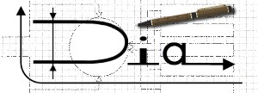
Dia is free and open source general-purpose diagramming software, developed as part of the GNOME project's office suite and was originally created by Alexander Larsson. Dia uses a controlled single document interface (CSDI) similar to GIMP and Sodipodi.
Dia has a modular design with several shape packages available for different needs: flowchart, network diagrams, circuit diagrams, and more. It does not restrict symbols and connectors from various categories from being placed together.
Dia is a gtk+ based diagram creation program released under the GPL license.
Dia is inspired by the commercial Windows program 'Visio', though more geared towards informal diagrams for casual use. It can be used to draw many different kinds of diagrams. It currently has special objects to help draw entity relationship diagrams, UML diagrams, flowcharts, network diagrams, and many other diagrams. It is also possible to add support for new shapes by writing simple XML files, using a subset of SVG to draw the shape.

It can load and save diagrams to a custom XML format (gzipped by default, to save space), can export diagrams to a number of formats, including EPS, SVG, XFIG, WMF and PNG, and can print diagrams (including ones that span multiple pages).

Facebook SDK
Apps on Facebook.com Building an app on Facebook.com gives us the opportunity to deeply integrate into our core user experience. Use the native functionality of Facebook such as Requests and Bookmarks to create an ideal social space for your users.

Twitter SDK
Twitter provides a SDK for developing application on top of Twitter SDK.

LinkedIn SDK
LinkedIn allows developers to build applications that run on LinkedIn user’s home and profile pages. Applications currently available can be seen and installed from the Application Directory. LinkedIn applications are developed using the OpenSocial development model

Analysis of the Project:
Daily notebook & Social Networking Updater software is divided into three major components. Such as:
- Daily notebook & Social Networking Updater GUI
- Daily notebook & Social Networking Updater Engine
- Daily notebook & Social Networking Updater Database

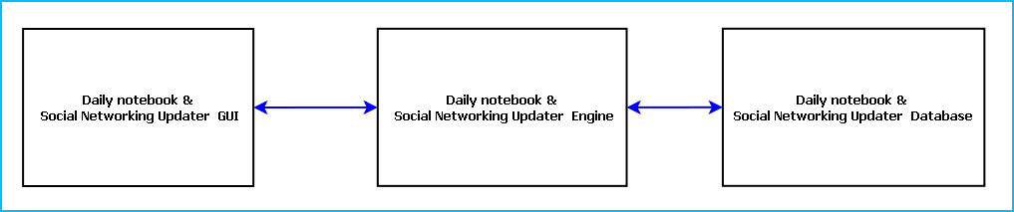
Figure: Main components of Daily notebook & Social Networking Updater

Daily notebook & Social Networking Updater GUI
Daily notebook & Social Networking Updater will allow user to add daily notes, update them in the social networking sites and view RSS feed updates of their favorite sites. The GUI module is divided into 14 components. Such as:
- View Manager  - Daily Note Interface  - Task / To Do Interface  - Common Controls  - Search Interface  - RSS FEED Interface  - Archive Interface | - Facebook Interface  - Twitter Interface  - Blogger Interface  - Linkedin Interface  - Google buzz Interface  - Orkut status Interface  - Engine Interactor

View Manger:
View Manager controls the interaction between different views. It handles the GUI flow and the look and feel of the application. It manages the components of the GUI. View Manger keeps track of user preferences and displays the data according to it.
View Manager enables user to choose the view to be displayed and sort the data entries according to name, time etc.
In this software variable number of views can be displayed. All the views can be arranged as a tabbed/ Split window.

Common Controls:
Common controls include several controls of the application. Such as: Menu Bar, Toolbar, status bar, Context Menu and progress bar.

Engine Interaction:
This module handles the interaction between GUI and Engine. This module defines all callback for the Engine events.
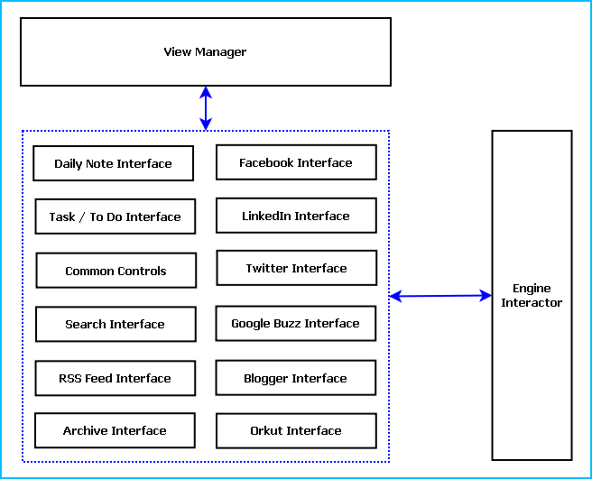
Figure: Different GUI Components

Search Interface
This interface enables user to search any of the updates, notes and RSS feeds from current view port as well as from the archived database. It will have provision for entering search item and selecting the type of search as well as advanced search options.

Facebook Interface
This interface will allow connecting to the facebook site, access login information. It will provide RSS feeds from facebook site. It will display only the text and link of the multimedia contents for time being.

Twitter Interface
This interface will allow connecting to Twitter site and gain the authentication. It will display user’s twitter stream and the other feeds he follows.

Daily Note Interface
This interface will allow user to insert notes and he can choose the services or sites to be updated also. The UI will have a text area where he can enter text and tick the check boxes corresponding to social networking sites to be updated.
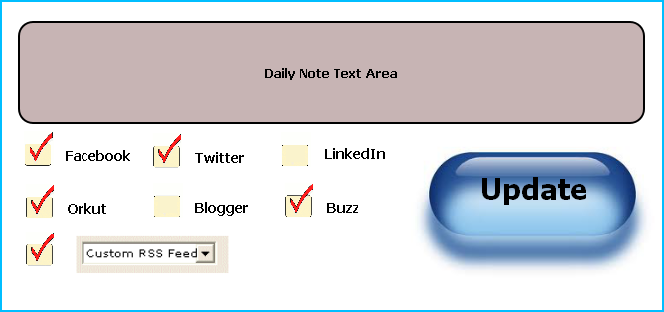
Figure: Daily Note Entry GUI Layout

Blogger Interface
This interface will allow authentication of Blogger access and display Blogger feeds which the user like to follow.

Linkedin Interface
This interface will display the updates from LinkedIn friends, InMails and connection requests. It will allow connecting the LinkedIn site.

Google buzz Interface
This interface will update the Google Buzz notifications from the user’s existing friends. It will also have an interface to login using Google Open ID for authentication.

Orkut status Interface
This interface will display Orkut updates, friend’s scraps, messages and other notifications. It will allow user to login using Orkut User name and password.

RSS FEED Interface
This will allow user to subscribe with any RSS feed and get regular updates from that feed.

Task / To Do Interface
This interface will allow user to add task list and modify it if required. User can add alarm or notification along with a task.

Archive Interface
It will allow user to archive old data. User can select data according time, size or service and archive them for saving disk space.

Daily notebook & Social Networking Updater Engine
Daily Notebook & Social Networking Updater Engine controls the logic and mechanism of the application. It processes the GUI requests and interacts with Database and the web feeds. This module is divided into 8 segments. Such as:
- Daily Note Handler
- Task / To Do Handler
- RSS Feed Watcher
- GUI Interactor
- Database Manager:
- Search Engine:
- Web Service Handler:
- Data Update Manager
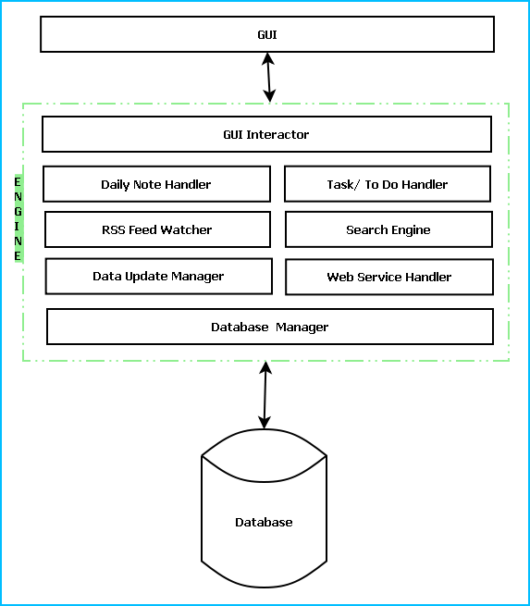
Figure: Engine layers along with interaction with GUI & DB.

Task / To Do Handler:
This module will process the user entered data for Task/ To Do list. It schedules the alarm notification depending on the user preferences.

Daily Note Handler:
Daily Note Handler processes the notes entered by the user. It saves the note in database by passing it to Database Manager. It also saves necessary information like user, time, account and other preferences. Depending on the user input passes the daily note content to the appropriate web service handlers.

RSS Feed Watcher:
This module will poll for RSS feed updates in specific websites. It will download the Feed change and pass it on to the appropriate handler.

GUI Interactor:
This module interacts with GUI module and serves GUI action request. It exposes events to GUI to notify some special actions along with required data.

Database Manager:
This module manages the database. It handles information saving in database, retrieval of information from database.

Search Engine:
Search engine enables rapid and efficient searching of data. Search Engine prepares search indexes depending most accessed data. It improves the efficiency and performance of the software.

Web Service Handler:
Web controller handles the interaction with web services like Facebook, Twitter, Orkut. Web service handler will associate a separate instance for each web service. It keeps track of authentication session, sends data and receives updates.

Data Update Manager:
It controls the incoming data from web service handlers and passes the updates to appropriate web service handler. It is a bridge between Daily Note handler and web service handlers. It validates the data depending on predefined inputs. If validation is failed it generates warning messages.

Daily notebook & Social Networking Updater Database
Daily notebook & Social Networking Updater Database will be an optimized database which will save updates from every web service as well as the notes entered by the user. We will use RDBMS concept.

Hardware & Software required for the application to run

Hardware Requirements
- Computer that has a 1.6GHz or faster processor
- 1 GB (32 Bit) or 2 GB (64 Bit) RAM
- 10 MB of available hard disk space
- DVD-ROM Drive / USB Port

Software Requirements
- Windows XP (x86) with Service Pack 3 / Windows Vista (x86) with Service Pack 2 / Windows 7 (x86)
- Microsoft .NET 4.0

E-R Diagram:
We will design a RDBMS for Daily notebook & Social Networking Updater. The entities and their attributes are listed below. Attributes in Bold letter is the unique key.
Entities | Attributes
Note | Note Id, Content, Time, Size, Web Service id, user
RSS Feed | RSS Feed Id , Web Service Id, Content, time, size
Daily notebook & Social Networking Updater | Sw Id, Web Services Supported, Users, Size
User | User Id, Name, Social Network Data, Preferences.
Web Service | Web Service Id, Authentication Data, Feed Data, Preferences.

Relationship between Entities:

- Daily notebook & Social Networking Updater has User → 1 : N
- Users post Notes → 1 : N
- Web Service generates Feeds → M : N

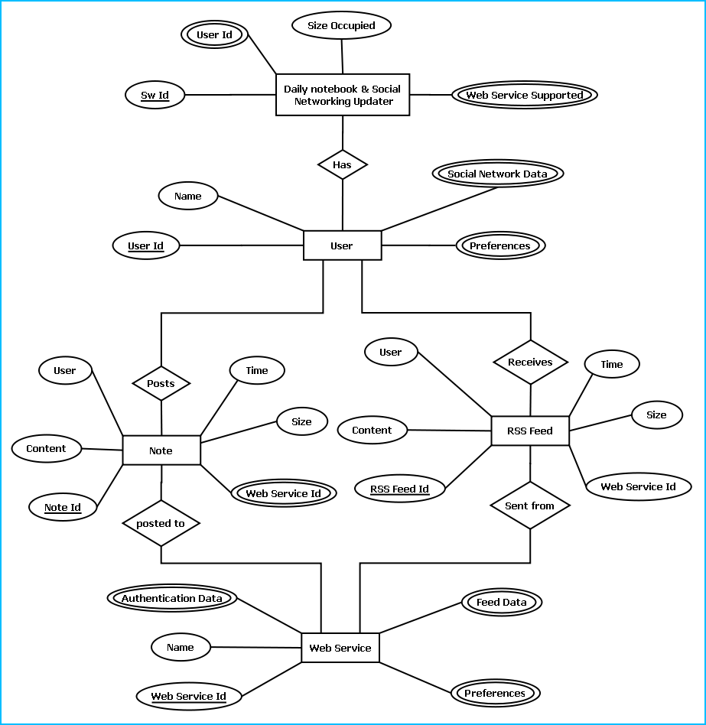
E-R Diagram of Daily notebook & Social Networking Updater

DESIGN DOCUMENT:

The user interface is developed using WPF.
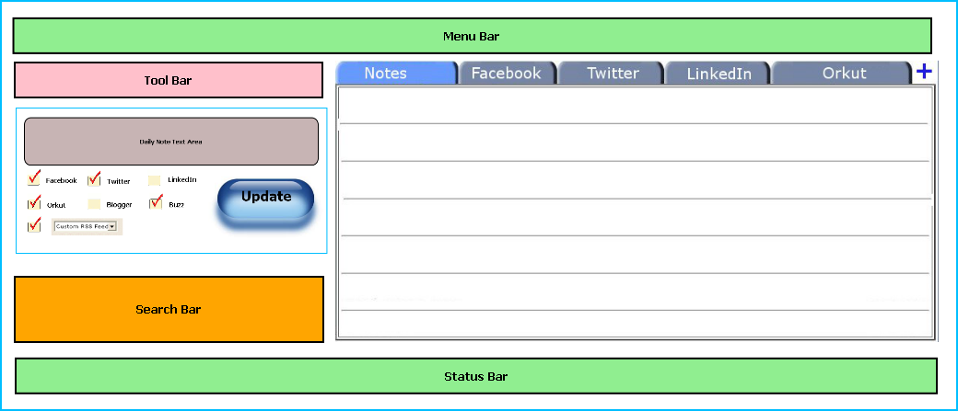
Figure: GUI layout & Placements

Menu bar contains the important features which can be accessed by shortcuts too. It is implemented using Menu control.
System.Windows.Controls.Menu
Namespace: System.Windows.Controls
Assembly: PresentationFramework (in PresentationFramework.dll)
Represents a Windows menu control that enables you to hierarchically organize elements associated with commands and event handlers.

Toolbar lists down the mostly used features. It is implemented using ToolBar control.
System.Windows.Controls.ToolBar
Namespace: System.Windows.Controls
Assembly: PresentationFramework (in PresentationFramework.dll)
Provides a container for a group of commands or controls.

Left navigation bar displays the tutorials available locally and online. This navigation bar is hide- able. It is implemented using the Expander control.
System.Windows.Controls.Expander
Namespace: System.Windows.Controls
Assembly: PresentationFramework (in PresentationFramework.dll)
Represents the control that displays a header that has a collapsible window that displays content.

The local contents are displayed in a TreeView control. And every contents are displayed in in a TreeViewItem.
System.Windows.Controls.TreeView
Namespace: System.Windows.Controls
Assembly: PresentationFramework (in PresentationFramework.dll)
Represents a control that displays hierarchical data in a tree structure that has items that can expand and collapse.

Online contents are displayed in a WebBrowser control. Users can select the content and purchase it from there.
System.Windows.Controls.WebBrowser
Namespace: System.Windows.Controls
Assembly: PresentationFramework (in PresentationFramework.dll)
Hosts and navigates between HTML documents. Enables interoperability between WPF managed code and HTML script.

Textpane displays the Texts. This is implemented using a TextBlock control.
System.Windows.Controls.TextBlock
Namespace: System.Windows.Controls
Assembly: PresentationFramework (in PresentationFramework.dll)
Provides a lightweight control for displaying small amounts of flow content.

Video and audio playing is implemented using MediaElement control.
System.Windows.Controls.MediaElement
Namespace: System.Windows.Controls
Assembly: PresentationFramework (in PresentationFramework.dll)
Represents a control that contains audio and/or video.

Images are displayed using Image control.
System.Windows.Controls.Image
Namespace: System.Windows.Controls
Assembly: PresentationFramework (in PresentationFramework.dll)
Represents a control that displays an image.

Drawing pane is implemented using InkCanvas control.
System.Windows.Controls.InkCanvas
Namespace: System.Windows.Controls
Assembly: PresentationFramework (in PresentationFramework.dll)
Defines an area that receives and displays ink strokes.

Statusbar displays the information about the application and the tutorial currently running. Its implemented using StatusBar Class.
System.Windows.Controls.Primitives.StatusBar
Namespace: System.Windows.Controls.Primitives
Assembly: PresentationFramework (in PresentationFramework.dll)
Represents a control that displays items and information in a horizontal bar in an application window.

Engine Design:
Reading & Writing XML:
In this application the tutorials are saved as XML file. The application will process the XML and play the tutorial. So we have implemented XML reader and writer logic. XML operations are done using .NET XML parser. Every XML element is represented as a XElement control.
System.Xml.Linq.XElement
Namespace: System.Xml.Linq
Assembly: System.Xml.Linq (in System.Xml.Linq.dll)
Represents an XML element.

Facebook Integration:
Facebook PHP SDK: The Facebook Platform is a set of APIs that make your application more social. Read more about integrating Facebook with your web site on the Facebook developer site.
This repository contains the open source PHP SDK that allows you to utilize the above on your website. Except as otherwise noted, the Facebook PHP SDK is licensed under the Apache Licence, Version 2.0 (http://www.apache.org/licenses/LICENSE-2.0.html)
Usage:
<?php

require './facebook.php';

$facebook = new Facebook(array(
'appId' => 'YOUR APP ID',
'secret' => 'YOUR API SECRET',
'cookie' => true, // enable optional cookie support
));
To make API calls:
try {
$me = $facebook->api('/me');
} catch (FacebookApiException $e) {
error_log($e);
}
Logged in vs Logged out:
if ($facebook->getSession()) {
echo '<a href="' . $facebook->getLogoutUrl() . '">Logout</a>';
} else {
echo '<a href="' . $facebook->getLoginUrl() . '">Login</a>';
}

Twitter Integration
Registering a twitter application: https://dev.twitter.com/apps/new
The Twitter API consists of three parts: two REST APIs and a Streaming API. The two distinct REST APIs are entirely due to history. Summize, Inc. was originally an independent company that provided search capability for Twitter data. Summize was later acquired and rebranded as Twitter Search. Rebranding the site was easy, fully integrating Twitter Search and its API into the Twitter codebase is more difficult. It is in our pipeline to unify the APIs, but until resources allow the REST API and Search API will remain as separate entities. The Streaming API is distinct from the two REST APIs as Streaming supports long-lived connections on a different architecture.
The Twitter REST API methods allow developers to access core Twitter data. This includes update timelines, status data, and user information. The Search API methods give developers methods to interact with Twitter Search and trends data. The concern for developers given this separation is the effects on rate limiting and output format. The Streaming API provides near real-time high-volume access to Tweets in sampled and filtered form.

LinkedIn Integration
LinkedIn has teamed up with some of the Internet’s premier companies to bring you new applications that enable you to collaborate on projects, get key insights, and present your work to the world’s largest professional network. Getting started is fast and easy, as you’ll be able to install and use your new applications in just seconds. Below you’ll find a brief description and video demos of our featured launch application partners.
LinkedIn allows developers to build applications that run on LinkedIn user’s home and profile pages. Applications currently available can be seen and installed from the Application Directory. LinkedIn applications are developed using the OpenSocial development model.
How to develop for the Platform: The LinkedIn application platform is not publicly available for all developers. We evaluate requests to develop for the LinkedIn platform from partners who have clearly compelling value to our users and who can rigorously follow our privacy policies. We are looking for applications that provide clear business utility to LinkedIn users. LinkedIn is not a place for sheep throwing. There is equal opportunity to build applications that apply to all LinkedIn users as there is to develop applications that apply to just a targeted portion of the user base. If you think you qualify and have a compelling user value.

Installer:
This software is packaged using Visual studio Installer utility. It provides a MSI file to be installed on end user side.

This installer will include all the required DLL to run this software .
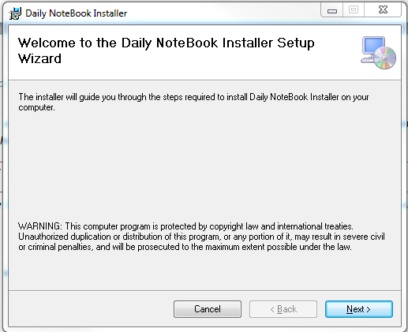
The users can browse the installation folder for this software and install the software in the desired path.
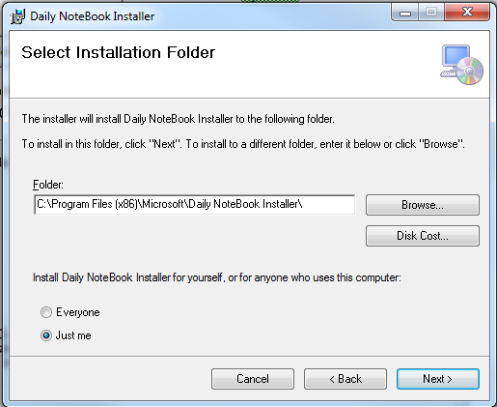
It will take some time to install the software in the PC and create shortcut icons on Desktop and program menus.
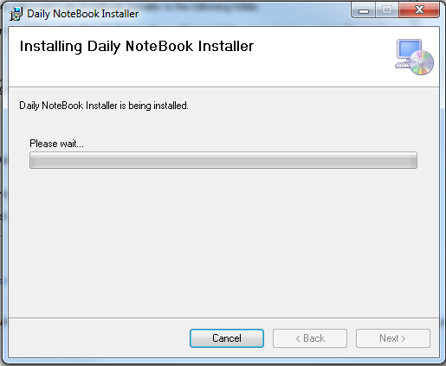

PROGRAMME CODE:
We cannot provide whole code base due to the company restrictions. The project structure looks like below mentioned image.
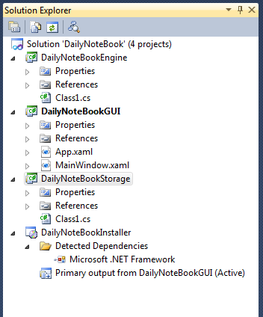

MainWindow.xml
<Window x:Class="WpfApplication1.MainWindow"
xmlns="http://schemas.microsoft.com/winfx/2006/xaml/presentation"
xmlns:x="http://schemas.microsoft.com/winfx/2006/xaml"
Title="Daily Notebook &amp; Social Networking Updater" Height="600" Width="800">
<DockPanel LastChildFill="True">
<Menu DockPanel.Dock="Top">
<MenuItem Header="File">
<MenuItem Header="New Status"/>
<MenuItem Header="Exit" Name="exitMenu" Click="exitMenu_Click"/>
</MenuItem>
<MenuItem Header="Edit">
<MenuItem Command="ApplicationCommands.Copy"/>
<MenuItem Command="ApplicationCommands.Cut"/>
<MenuItem Command="ApplicationCommands.Paste"/>
</MenuItem>
<MenuItem Header="Help">
<MenuItem Header="About" Name="aboutMenu" Click="aboutMenu_Click"></MenuItem>
<MenuItem Header="Tutorial"></MenuItem>
</MenuItem>
</Menu>
<ToolBar DockPanel.Dock="Top">
<Button>New Status</Button>
<Separator></Separator>
<Button>Settings</Button>
</ToolBar>
<StatusBar DockPanel.Dock="Bottom" >
<Label Content="Not connected"></Label>
</StatusBar>
<DockPanel DockPanel.Dock="Top" LastChildFill="True">
<Expander Width="200" DockPanel.Dock="Left" ExpandDirection="Right" IsExpanded="True">
<UniformGrid Columns="1">
<TextBox Height="100"></TextBox>
<DockPanel LastChildFill="True">
<Button DockPanel.Dock="Right">Update</Button>
<UniformGrid Columns="1">
<CheckBox>Facebook</CheckBox>
<CheckBox Width="126">Twitter</CheckBox>
<CheckBox>LinkedIn</CheckBox>
<CheckBox>Orkut</CheckBox>
</UniformGrid>
</DockPanel>
<TextBox Margin="10" Height="40" HorizontalContentAlignment="Center" VerticalContentAlignment="Center">Search</TextBox>
</UniformGrid>
</Expander>
<TabControl Name="tabControl1">
<TabItem Header="Notes" Name="notesTabItem">

</TabItem>
<TabItem Header="Facebook" Name="fbTabItem">
<DockPanel LastChildFill="True">
<StackPanel DockPanel.Dock="Top" Orientation="Horizontal">
<Button Name="fbLoginBtn" Click="fbLoginBtn_Click" Margin="10">Login To FB</Button>
<Button Content="Refresh Fb Status" Margin="10" Name="fbRefreshButton" />
</StackPanel>
<ListView></ListView>
</DockPanel>
</TabItem>
<TabItem Header="Twitter" Name="twitterTabItem">
<DockPanel LastChildFill="True">
<StackPanel DockPanel.Dock="Top" Orientation="Horizontal">
<Button Name="twitLoginBtn" Click="twitLoginBtn_Click" Margin="10">Login To Twitter</Button>
<Button Content="Refresh Tweets" Margin="10" Name="twitRefreshBtn" />
</StackPanel>
<ListView></ListView>
</DockPanel>
</TabItem>
<TabItem Header="LinkedIn" Name="linkedinTabItem">
<DockPanel LastChildFill="True">
<StackPanel DockPanel.Dock="Top" Orientation="Horizontal">
<Button Name="linkedinLoginBtn" Click="linkedinLoginBtn_Click" Margin="10">Login To LinkedIn</Button>
<Button Content="Refresh Linkedin Updates" Margin="10" Name="linkedInRefreshBtn" />
</StackPanel>
<ListView></ListView>
</DockPanel>
</TabItem>
<TabItem Header="Orkut" Name="orkutTabItem">
<DockPanel LastChildFill="True">
<StackPanel DockPanel.Dock="Top" Orientation="Horizontal">
<Button Name="orkutLoginBtn" Click="orkutLoginBtn_Click" Margin="10">Login To Orkut</Button>
<Button Content="Refresh Orkut Updates" Margin="10" Name="orkutRefreshBtn" />
</StackPanel>
<ListView></ListView>
</DockPanel>
</TabItem>
</TabControl>
</DockPanel>
</DockPanel>
</Window>

MainWindow.xml.cs
using System;
using System.Collections.Generic;
using System.Linq;
using System.Text;
using System.Windows;
using System.Windows.Controls;
using System.Windows.Data;
using System.Windows.Documents;
using System.Windows.Input;
using System.Windows.Media;
using System.Windows.Media.Imaging;
using System.Windows.Navigation;
using System.Windows.Shapes;

namespace WpfApplication1
{
/// <summary>
/// Interaction logic for MainWindow.xaml
/// </summary>
public partial class MainWindow : Window
{
private void exitMenu_Click(object sender, RoutedEventArgs e)
{
this.Close();
}

private void aboutMenu_Click(object sender, RoutedEventArgs e)
{

MessageBox.Show("Daily Notebook & Social Networking Updater V-1.0 \n Developed By Sk Monirul Islam");

}

private void fbLoginBtn_Click(object sender, RoutedEventArgs e)
{

}

private void twitLoginBtn_Click(object sender, RoutedEventArgs e)
{

}

private void linkedinLoginBtn_Click(object sender, RoutedEventArgs e)
{

}

private void orkutLoginBtn_Click(object sender, RoutedEventArgs e)
{

}
}
}

Facebook App:
<?php

$app_id = YOUR_APP_ID;

$canvas_page = YOUR_CANVAS_PAGE_URL;

$message = "Apps on Facebook.com are cool!";

$feed_url = "http://www.facebook.com/dialog/feed?app_id="
. $app_id . "&redirect_uri=" . urlencode($canvas_page)
. "&message=" . $message;

if (empty($_REQUEST["post_id"])) {
echo("<script> top.location.href='" . $feed_url . "'</script>");
} else {
echo ("Feed Post Id: " . $_REQUEST["post_id"]);
}
?>

<?php

$app_id = YOUR_APP_ID;

$canvas_page = YOUR_CANVAS_PAGE_URL;

$message = "Would you like to join me in this great app?";

$requests_url = "http://www.facebook.com/dialog/apprequests?app_id="
. $app_id . "&redirect_uri=" . urlencode($canvas_page)
. "&message=" . $message;

if (empty($_REQUEST["request_ids"])) {
echo("<script> top.location.href='" . $requests_url . "'</script>");
} else {
echo "Request Ids: ";
print_r($_REQUEST["request_ids"]);
}
?>

Twitter App
<?php
function updateTwitter($status)
{
$username = 'xxxxxx';
$password = 'xxxx';
$url = 'http://api.twitter.com/1/statuses/update.xml';
$postargs = 'status='.urlencode($status);
$responseInfo=array();
$ch = curl_init($url);
curl_setopt($ch, CURLOPT_CONNECTTIMEOUT, 2);
curl_setopt($ch, CURLOPT_RETURNTRANSFER, 1);
curl_setopt ($ch, CURLOPT_POST, true);
// Give CURL the arguments in the POST
curl_setopt ($ch, CURLOPT_POSTFIELDS, $postargs);
// Set the username and password in the CURL call
curl_setopt($ch, CURLOPT_USERPWD, $username.':'.$password);
// Set some cur flags (not too important)
$response = curl_exec($ch);
if($response === false)
{
echo 'Curl error: ' . curl_error($ch);
}
else
{
echo 'Operation completed without any errors<br/>';
}
// Get information about the response
$responseInfo=curl_getinfo($ch);
// Close the CURL connection curl_close($ch);
// Make sure we received a response from Twitter
if(intval($responseInfo['http_code'])==200){
// Display the response from Twitter
echo $response;
}else{
// Something went wrong
echo "Error: " . $responseInfo['http_code'];
}
curl_close($ch);
}
updateTwitter("Just finished a sweet tutorial on http://brandontreb.com");
?>

INPUT/OUTPUT SCREEN:

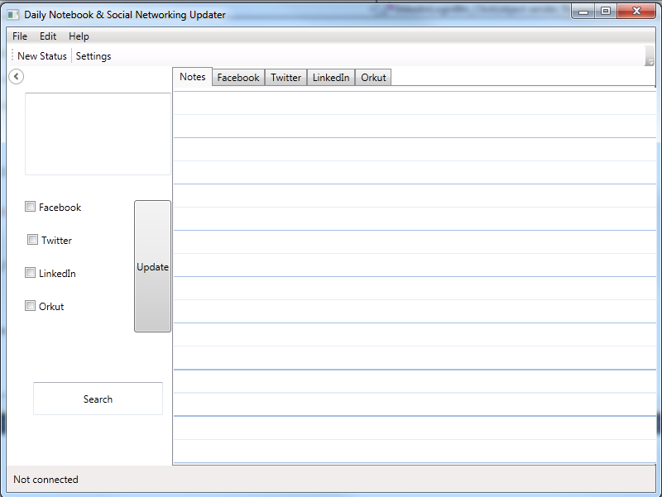

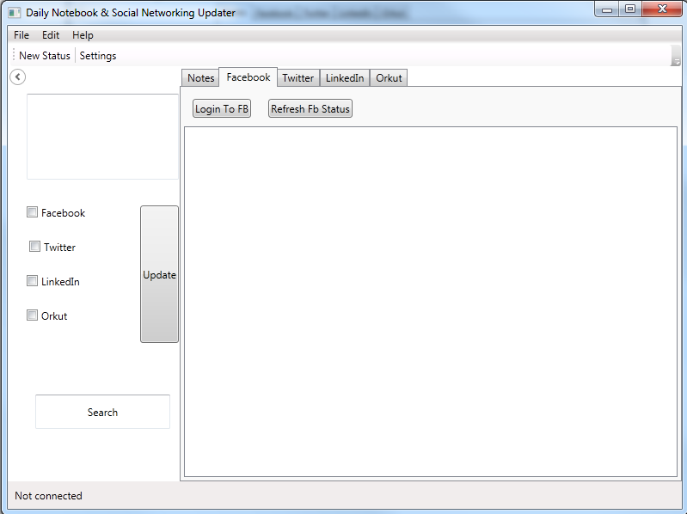

SECQURITY MEASURES:
- Facebook, twitter, LinkedIn uses OAuth to authorize the user login.
- It saves password information by encrypting it.

LIMITATION OF THE PROJECT:
- It only provides the updates , not other extra features
- It works on only Windows XP & Windows 7.
- Auto update is not event based.

Any Client/Industry:

E-Komfort Zone
Bamangachi Station Road,
P.O: Bamangachi, P.S: Barasat,
Dist: North 24 Pgs
West Bengal- 743706

Future Scope and Further enhancement of the project:

- Now it will display the text based RSS feeds and link of the multimedia contents. We will display the Multimedia contents like Video, Audio & Image in future.
- To support UNIX / Linux Based Operating systems.
- To Support Mobile Operating systems for Symbian, Meego & Android.

Bibliography:
- http://www.google.co.in
- http://en.wikipedia.org
- http://msdn.microsoft.com/en-us/
- http://www.microsoft.com/en-us/default.aspx
- http://www.codeplex.com/
- http://stackoverflow.com/
- http://www.codeguru.com/
- http://www.w3schools.com
- http://www.thewpfblog.com/

----------------------------- Thank You-------------------------

